**Relational Database Assignment - Due 3/12/2023**

In this assignment, you will create a database named student_info.db that holds the following information about students at a college:

* The student’s name
* The student’s major
* The department in which the student is enrolled

The database should have the following tables: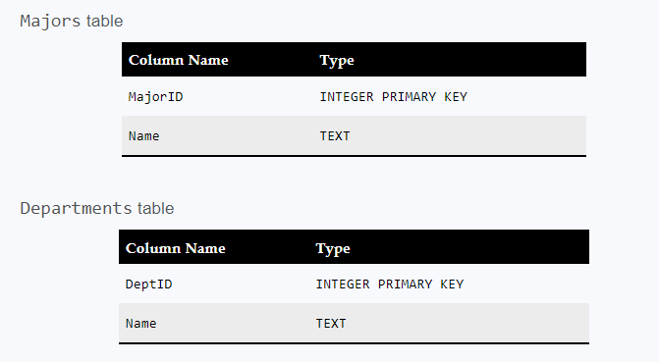

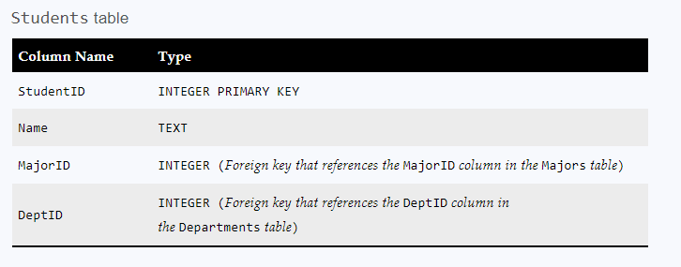

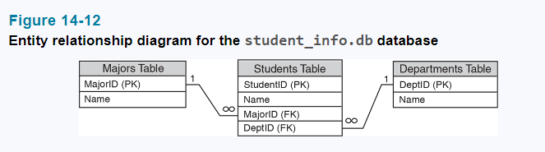

* Write a program that creates the database and the tables.
* Write a program that performs CRUD operations on the Majors table. Specifically, the program should allow the user to do the following:

___ Add a new major

___ Search for an existing major

___ Update an existing major

___ Delete an existing major

___ Show a list of all majors

* Write a program that performs CRUD operations on the Departments table. Specifically, the program should allow the user to do the following:

___ Add a new department

___ Search for an existing department

___ Update an existing department

___ Delete an existing department

___ Show a list of all departments

* Write a program that performs CRUD operations on the Students table. Specifically, the program should allow the user to do the following:

___ Add a new student

___ Search for an existing student

___ Update an existing student

___ Delete an existing student

___ Show a list of all students

When adding, updating, and deleting rows, be sure to enable foreign key enforcement. When adding a new student to the Students table, the user should only be allowed to select an existing major from the Departments table, and an existing department from the Departments table.